Advanced Computer Graphics
README – Project 1

Akshara Reddy Nookala
811330459
anookala@kent.edu

Project Overview
This project implements the first phase of a full ray tracer, focusing on the Phong local illumination model. The base ray tracer framework (provided by the instructor) was extended to generate realistic smooth shading on multiple 3D objects- spheres and walls- within a virtual scene. The result demonstrates how light interacts locally with surfaces to create ambient, diffuse, and specular reflections.

Steps to Execution

1. Software Setup

- Download and install Microsoft Visual Studio (Community Edition).
- Make sure the C++ development tools are installed.
- Download the provided project package ray_tracer_kent.zip from Canvas.

2. Project Initialization

• Extract the contents of the downloaded ZIP file to your computer.
• Open Visual Studio → File → Open Project/Solution → select RayTracer.sln
from the extracted folder.

3. Build and Run

- Build the solution by clicking Build → Build Solution or pressing Ctrl + Shift + B.
- After building successfully, a Debug folder will be created containing the RayTracer.exe file.
- Copy glut32.dll into the same Debug folder.
- Run the project by clicking Start Debugging (F5) or Start Without Debugging (Ctrl + F5)

4. Output

- A rendered image window will open, showing the 3D scene with spheres
- and walls.
- The image demonstrates smooth light reflection and shading effects.

Implementation Details

- Implemented Phong local shading in the ray tracer framework to create realistic lighting.
- Modified the color values of spheres and walls in the Scene.cpp file.
- Added ambient lighting and adjusted the light source position to achieve smooth transitions between light and shadow.
- The shading logic for each object type is written in:
    - Sphere.cpp → Sphere::shade()
    - Wall.cpp → Wall::shade()
- Custom RGB values were assigned to differentiate each wall and sphere.

Changes Made

- Updated object colors for all walls and spheres.
- Adjusted light intensity and viewing position for better illumination.
- Generated new output image showing clear shading differences between objects.

Output Images:

Initial Output (Without Phong Shading):

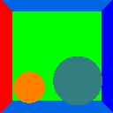
Final Output (With Phong Shading):

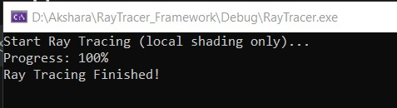

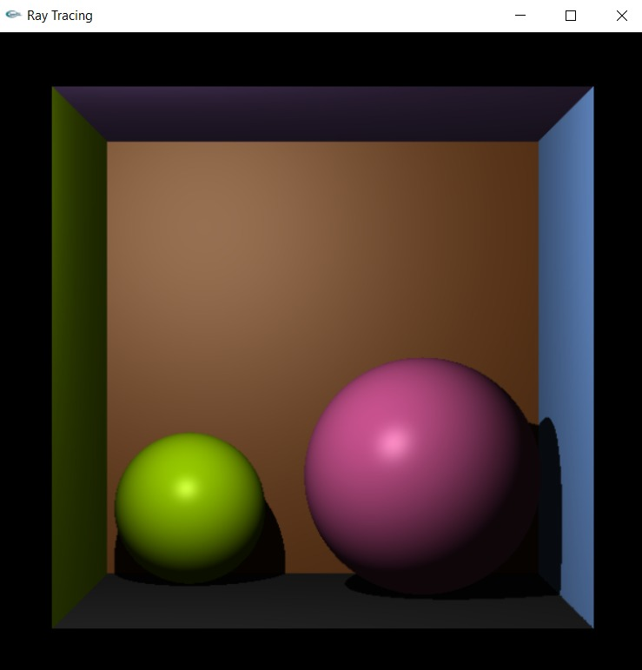

Conclusion
This project successfully implements Phong local shading within the provided ray tracer
framework. The final output shows smooth shading and realistic lighting effects across the
3D objects, fulfilling all requirements set by the instructor.

